3D Printing
  - Key Revision Facts: GCSE Technology

Additive Manufacturing
3D printing, or additive manufacturing, is constructing a three-dimensional object from a CAD model or a digital 3D model. The term "3D printing" can refer to various processes in which material is deposited, joined, or solidified under computer control to create a three-dimensional object, with the material being added together (such as plastics, liquids, or powder grains being fused together), typically layer by layer.
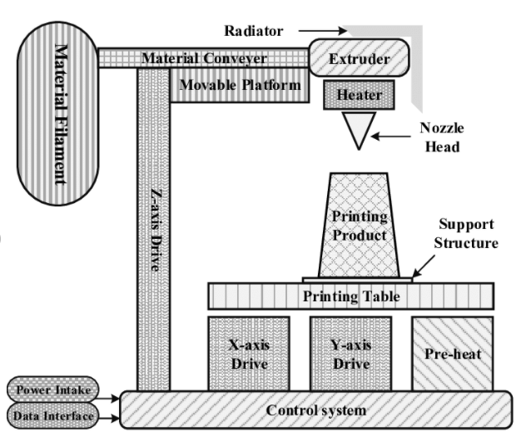

Stereolithography
Stereolithography is a form of 3D printing technology used for creating models in a layer by layer fashion using photochemical processes by which light causes chemical monomers to fuse together to form polymers.

Pro's and Cons of 3D Printing
Advantages of 3D Printing | Disadvantages of 3D Printing
3D printing has improved time from conception to implementation. | Inefficient for large production batches.
3D printing enables design concepts that aren't capable of being produced in any other medium. | Most of the materials used in 3D printing are more expensive than similar materials used in other manufacturing processes, like injection molding or CNC machining.
Eco-friendly process because the process has very little waste. | 3D printing can also be used for counterfeiting or just stealing somebody else's design and replicating it.

Download
More Key Fact Revision sheets can be downloaded from
www.andrew-seaford.co.uk/revision

Version information
Date | Arthur | Comment
17-Jan-2021 | Andrew Seaford | Initial release.

